Meeting Notes
Group D

Date: |  | Time:
2/11/2025 |  | 10:00 AM UK

In attendance
Andrei Tapu, Valentine Ofili, Ariel Mella, Mohammed Khalid

Recording:
Zoom and transcript available at: https://drive.google.com/drive/folders/1Ol83TJ5lzDYfZ3fkNoC92xvJvyDpCeiG?usp=sharing

Agenda and Objectives:
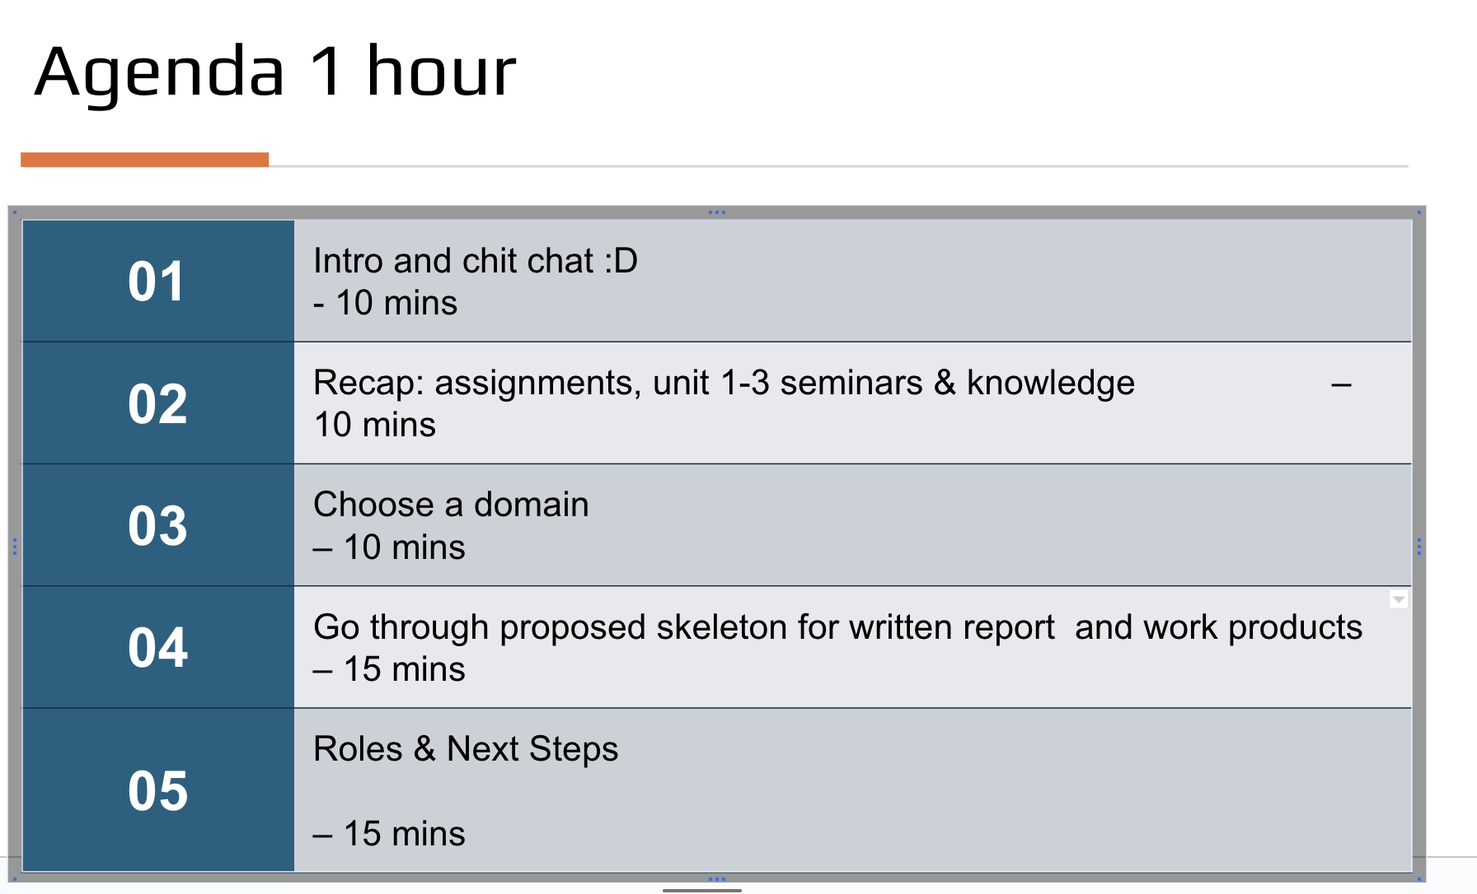
Deck with agenda details at: https://docs.google.com/presentation/d/1r9N9ruu3xWmHuk731BdcYXMrKsUF3ll9/edit?usp=drive_link&ouid=113786110083556405902&rtpof=true&sd=true

Key development & Discussion points
- Team intro:
Andrei Tapu, UK, Consultant, MSc AI doing the 5th module
Valentine Offili, UK, Full Stack engineer Java mainly but Python as well, Cloud, MSc AI doing the 3rd module
Ariel Mella, Germany, Sales & Consulting, Infrastructure, MSc AI doing the 2nd module
Mohammed Khalid, Qatar, Mechanical Engineer, MSc AI doing the 2nd module

- Communication channels, collaboration:
Google Drive will be used to share all kind of files Ariel to maintain, everyone write access
Andrei suggest to use google docs embebbed collaboration facility, comments, etc. - >Everyone agrees.
Zoom will be used for meetings both group and 1:1. Recordings and transcript by default, only available to the team -no outside permissions.
Whatsapp messaging for day 2 day interaction, both direct and Group D group.

- Everyone shared a quick recap of learned and assignment brief.
  - Expectations:
Ariel emphasizes objective of high Distinction grade. Everyone agrees.
Deadline for group activity: December 1st delivery
- Domain from assignment discussed.

Agreement: Forensics is chosen,
Rational: simplicity, clear link problem -> solution, appetite to learn, no previous specific experience with such a solution.
Note: no one had experience with agents before

- Written report
Ariel had prepared a proposal for written report containing the “skeleton” for sections, content, units and theory map, references, length. As well as a proposal for work products, i.e.: which assets or work products needs to be develop to “feed” the written report, understanding the written report is the “outcome” of developing the solution and the work products are the actual solution development reflected in each domain such as design decisions, problem, environment, requisites, design diagrams, agent design, etc.
Due to length and complexity it is defined that everyone will do an offline review and either accept or proposed changes by next meeting. Additionally, each team member will bring a proposal of which content can be owned based on “best man for the job” criteria, i.e.: willingness, experience, knowledge, learning ability and time.

Link to written report proposal: https://docs.google.com/document/d/12F-pqlGjUM7MzVyOLFm7VRftvIrF9Tep/edit?usp=drive_link&ouid=113786110083556405902&rtpof=true&sd=true
Link to work products proposal: https://docs.google.com/document/d/13fYgix8y4lc_7CCfxkRYMrQ9sMPGdse6/edit?usp=drive_link&ouid=113786110083556405902&rtpof=true&sd=true
Ariel expressed that would seek Tutor validation once all agree with the written report skeleton, as per Ariel:Tutor discussion in previous seminar. This will provide validation on right path.

- Roles
Due to 5, roles cannot be assigned yet. Will be discussed in out next meeting.
Ariel self-nominated as “Administrative lead” owning logistics, comm and collaboration administration, cadence and project management activities, etc.. Everyone agrees.

Outcome & Next steps
Everyone does a deep dive on proposed skeleton (written report) and work products document before next call. Comments and proposed changes by next call.
Roles proposal from each, where each can contribute the best
Based on previous, a project plan with timeline will be drafted
Individual and recurrent group calls will be scheduled for the rest of the available time.
Based on all above, which should be concluded by or within our next call, we expect to divide the work
Next call expectations:
- all input ready to draft project plan,
- timeline,
- roles and content distribution,
- Setup cadence both group and 1:1

Next Meeting
Next group meeting: 5th Nov 2025 7 PM UK
1:1 meeting: no schedule yet

